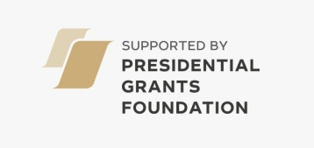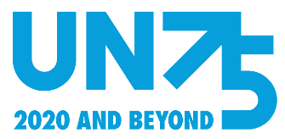

**International Youth Competition of Scientific, Scientific-Practical and Sci-Fi Works HORIZON-2100'22**

**Young people aged 16 to 26 from any country and of any nationality are invited until November 30, 2022 to register and submit a work for the competition:**

In English - <http://www.futurible.space/en/project/horizon-2022/>

In Russian - <http://www.futurible.space/ru/project/horizon-2022/>

**The competition is held in two nominations:**

- The best scientific article, research or scientific-practical work that reflects the scientific vision of the future of the planet and humanity at the turn of 2100 and the prospects for the development of various scenarios.

- The best science-fiction work, science-fiction story, essay, reportage, article, etc. that describes imaginary, innovative and original ideas, fantastic events, processes and future prospects at the turn of the year 2100, giving them a scientific explanation.

**COMPETITION WINNERS GET TO**:

- participate in the International Youth Foresight Forum "World 2100: Global Trends and the Future through the Eyes of the Young" ( February 5 to February 9, 2023), where diplomas will be awarded.

- have their works presented for the world to see at: <http://www.futurible.space/en/winners/>

Certificates in PDF format will be received by all participants.

**Available categories for entry into the competition:**

|  |  |
| --- | --- |
| PERSON OF THE FUTURE  ENERGY OF THE FUTURE  FUTURE OF SOCIETY  THE FUTURE OF THE ENVIRONMENT  FUTURE OF THE GLOBAL WORLD | FUTURE OF SCIENCE  FUTURE OF TECHNOLOGY  THE FUTURE OF HUMANITY'S ENVIRONMENT  FUTURE OF THE ECONOMY |

**To register and submit a work for the competition, find more information on the categories or read the terms of participation, please follow the link below:** <http://www.futurible.space/en/project/horizon-2022/>

*\*\*\**

*This year’s HORIZON 2100 Competition provides a chance to share your vision of the future and to offer ideas and projects for building the amazing world of 2100.*

*HORIZON 2100 is an annual competition that is organized for young and active thinkers from different countries, who can carry out creative research for scientific ideas, hypotheses or science fiction about the distant future at the turn of the year 2100.* *Over the past several years, the project has already involved more than 1200 participants and experts from 63 countries!*

**The working languages ​​of the project are Russian and English.**

For any questions in English, please contact by mail - [contest2100@futurible.space](mailto:contest2100@futurible.space)

For any questions in Russian, please contact by mail - [horizon2100@futurible.space](mailto:horizon2100@futurible.space)